***Sample Power BI Report***

***Design Document Fragment***

***Reports***

|  |  |
| --- | --- |
| *Date:* | *2025-03-24* |
| *Version:* | *0.4* |
| *Author:* | *Greg Philps* |

***Table of Contents***

1. Introduction 3

2. Scope of Work 3

3. Workflow 3

4. Issues 3

5. Business Rules 3

6. Data 3

7. Reports 3

7.1. Common 3

7.1.1. Theme 3

7.1.2. Filters 4

7.1.3. Navigation 5

7.1.4. Page Header 6

7.1.5. Page Footer 7

7.1.6. Slicers 7

7.2. Specific 8

7.2.1. Semantic Model (specific) 8

7.2.2. AR01 – All Invoices 9

7.2.3. AR02 – Current Invoices 10

7.2.4. AR03 – Upcoming Invoices 10

7.2.5. AR04 – Historical Invoices 11

# Introduction

*… see sample fragment 01 …*

# Scope of Work

*… see sample fragment 01 …*

# Workflow

*… see sample fragment 02 …*

# Issues

*… see sample fragment 02 …*

# Business Rules

*… see sample fragment 02 …*

# Data

*… see sample fragment 03 …*

# Reports

The reports in the project not only share a theme and a common data model, but there are other common items as well (e.g., theme, navigation, etc.). The items that are specific to an individual report (e.g., filters, visuals, etc.) are described separately below.

## Common

The design features that will be common to all reports in the project are described below.

### Theme

The theme of the report(s) is consistent, and the major items, including page size, colours, fonts, font sizes, etc., are described below.

| **ID** | **Item** | **Description** | **Notes** |
| --- | --- | --- | --- |
| *T-1* | *Page* | *Desktop:*  *Canvas size – 1600 by 900*  *Canvas background – light grey (#F0F0F0)*  *Wallpaper – none*  *Filter cards – default colours*  *Mobile:*  *n/a* | *pixels, width by height* |
| *T-2* | *Colours, Main* | *Shades of blue*  *#8BC7F7*  *#46B3F3*  *#009FEF*  *#008CEE*  *#0078ED*  *#0050EB*  *#0641C8*  *#0B31A5* | *Based on “Storm” theme included with Power BI Desktop* |
| *T-3* | *Colours, Sentiment* | *Green-yellow-red (i.e., “stoplight”)*  *Negative – red (#E81123)*  *Positive – green (#3BB44A)*  *Neutral – yellow (#F2C811)* |  |
| *T-4* | *Fonts* | *Visual titles – Segoe UI Semibold, 12 pt, black (#000000)*  *Visual subtitles – Segoe UI, 10 pt, dark grey (#969696)*  *Axis labels – Segoe UI, 8pt, black*  *Axis titles – none (disabled; rather, include in visual title)*  *Data labels – Segoe UI, 8pt, black*  *Callout values - Segoe UI Semibold, 18 pt, black* |  |
| *T-5* | *Visuals* | *Padding (pixels) - 4/4/4/4*  *Rounded corners (visuals) – 8 pixels*  *Rounded corners (cards, buttons) – 4 pixels*  *Background Colour – white (#FFFFFF)*  *Shadow – none*  *Glow – none* |  |
| *T-6* | *Miscellaneous* | *Visual Titles - off*  *Icons - off*  *Grid lines – light grey (#E3E3E3)*  *Tooltips – Modern*  *Pages – Only 1 visible, all others hidden* |  |

### Filters

The filters that will be applied to every report are described below:

* Only include active customers (i.e., those with active invoices)
* Only include active invoices (i.e., those with non-deleted invoices)
* Only include invoices from the current and past two calendar years

Here’s an example.

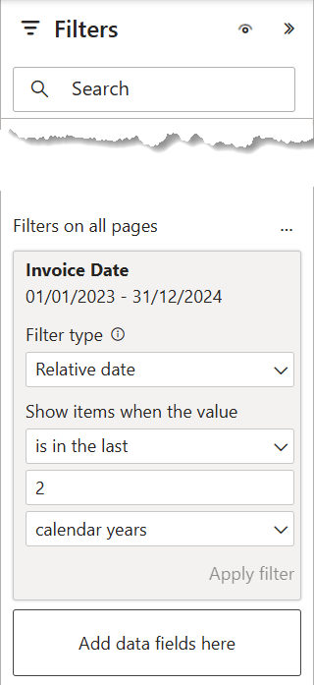

The filters specific to each report are described in their respective sections below.

### Navigation

A Power BI App will not be used to deliver the reports in this project, but rather **standalone** **navigation** will be used in each report, with items arranged as a 2-level top bar with “bounce” (subtle changes during mouseover and selection [e.g., font size, font colour, background colour, underline, etc.]) so users intuitively know where they are and how to navigate.

An information overlay can also be added to provide additional identification and illustration of the use of the navigation items. Many design tools can be used for such an effort.

Here's a quick procedure:

* Ensure the Power BI report is finished
* Grab a screenshot of final Power BI report page
* Edit the screenshot image in a design tool
* Overlay a full-screen rectangle (no border, partially transparent)
  + *The Power BI report screenshot image is now in the background*
* Add callouts for the navigation features as desired
* Hide or remove the background image
* Save the image (as picture)
* Add the image to the Power BI Desktop file (expand to full-screen)
* Add 2 bookmarks (panel open, panel closed)
* Add info button to activate the panel open bookmark
* Edit the image action to activate the panel closed bookmark

*Guy in a Cube* posted a video back in 2021 illustrating such a process:

<https://www.youtube.com/watch?v=yYr_SlG8bpw>

The items that will be included are described below.

| **ID** | **Name (Category / Subcategory)** | **Design / Selected / Unselected / Hover** |
| --- | --- | --- |
| *N-1* | *Invoices* | *DESIGN:*   * *Type=button* * *Shape=any, with border=off* * *Action=page navigation (subcategory 1)*   *DEFAULT (selected):*   * *Font=Segoe UI, white, 10 pt* * *Background=dark blue* * *Navigation=page, Invoices-All*   *DEFAULT (unselected):*   * *Font=Segoe UI, medium grey, 10 pt* * *Background=medium blue* * *Navigation=page, Invoices-All*   *HOVER:*   * *Font=Segoe UI, dark grey,* ***11 pt*** * *Background=medium grey* * *Navigation=page, Invoices-All* |
| *N-2* | *Invoices / All* | *(same as N-1 above)* |
| *N-3* | *Invoices / Current* | *(same as N-1 above, but with adjusted page navigation and selected and unselected defaults reversed)* |
| *N-4* | *Invoices / Upcoming* | *(same as N-1 above, but with adjusted page navigation and selected and unselected defaults reversed)* |
| *N-5* | *Invoices / Historical* | *(same as N-1 above, but with adjusted page navigation and selected and unselected defaults reversed)* |

*NOTE: Drill-through is not navigation and is rather described in each specific report.*

### Page Header

The elements that will be present in the header of each page of each report are described below.

* Report title
* Horizontal 2-level navigation menu (level 1 = category [above], level 2 = subcategory, or page [below])
* Invoices
  + All
  + Current
  + Upcoming
  + Historical
* Customers
  + Level
  + Tier
  + Country
* Other
  + Addresses
  + Known Issues
* Language slicer
  + EN/FR
* Last data refresh date (from the common dataset used by the report)
  + *Note: this will reflect the last date/time the dataset was refreshed by the Power BI Service, and is not indicative of the date/time that the data was last extracted from the source systems)*

### Page Footer

The elements that will be present in the footer of each page of each report are described below.

* Line – Separator (grey)
* Image – Logo (at left)
* Textbox – Filter Selections (in middle)
* Textbox (or Card) – Report ID / Version / Version Date (at right)
* Textbox (or Card) – Dataset ID / Version / Version Date (at right)

### Slicers

The slicers that will be included on each page of each all report are described below.

| **ID** | **Slicer** | **Design Features / Data / Notes** |
| --- | --- | --- |
| *n/a* | *General* | *Title=Segoe UI Semibold, 10 pt*  *Values=Segoe UI, 8 pt*  *Style=dropdown*  *Selection=multi-select; CTRL off; Select All off*  *Header icons=off*  *Search box=enabled* |
| *S-1* | *Fiscal year* | *Data=Dates[Fiscal Year]*  *Notes=search box unavailable as numeric data* |
| *S-2* | *Fiscal quarter* | *Data=Dates[Fiscal Quarter]*  *Notes=search box unavailable as numeric data* |
| *S-3* | *Date range* | *Type=between*  *Slider=on, responsive off*  *Data=Dates[Date]* |
| *S-4* | *Province* | *Type=text*  *Data=Countries[Province]* |
| *S-5* | *City* | *Type=text*  *Data=Countries[City]* |

## Specific

### Semantic Model (specific)

Describe the design of each specific semantic model in each specific report, including all fact tables, dimension (or lookup) tables, and supporting tables.

Assign an [ID] to each relationship and fully describe it, including the fields/columns that will be used to link tables, the cardinality, and the directionality of each relationship.

*(Note: This is the design intent, not the implementation; the DAX INFO functions will be used in the appendices [a subsequent issue] to extract the actual relationships from the developed model.)*

| **ID** | **From (table[column])** | **To (table[column])** | **Cardinality / Directionality** |
| --- | --- | --- | --- |
| *CR-1* | *Dates[Date]* | *Invoices[Date]* | *C=one-to-many*  *D=single* |
| *CR-2* | *Customers[Customer ID]* | *Invoices[Customer ID]* | *C=one-to-many*  *D=single* |

Include a semantic model image for each specific report that will be using an internal data model (rather than the external common data model) and arrange tables for clarity (e.g., waterfall design, with dimension [lookup] tables at the top, fact tables in the middle, supporting tables in the bottom-left, and measure tables in the top-right, etc.)

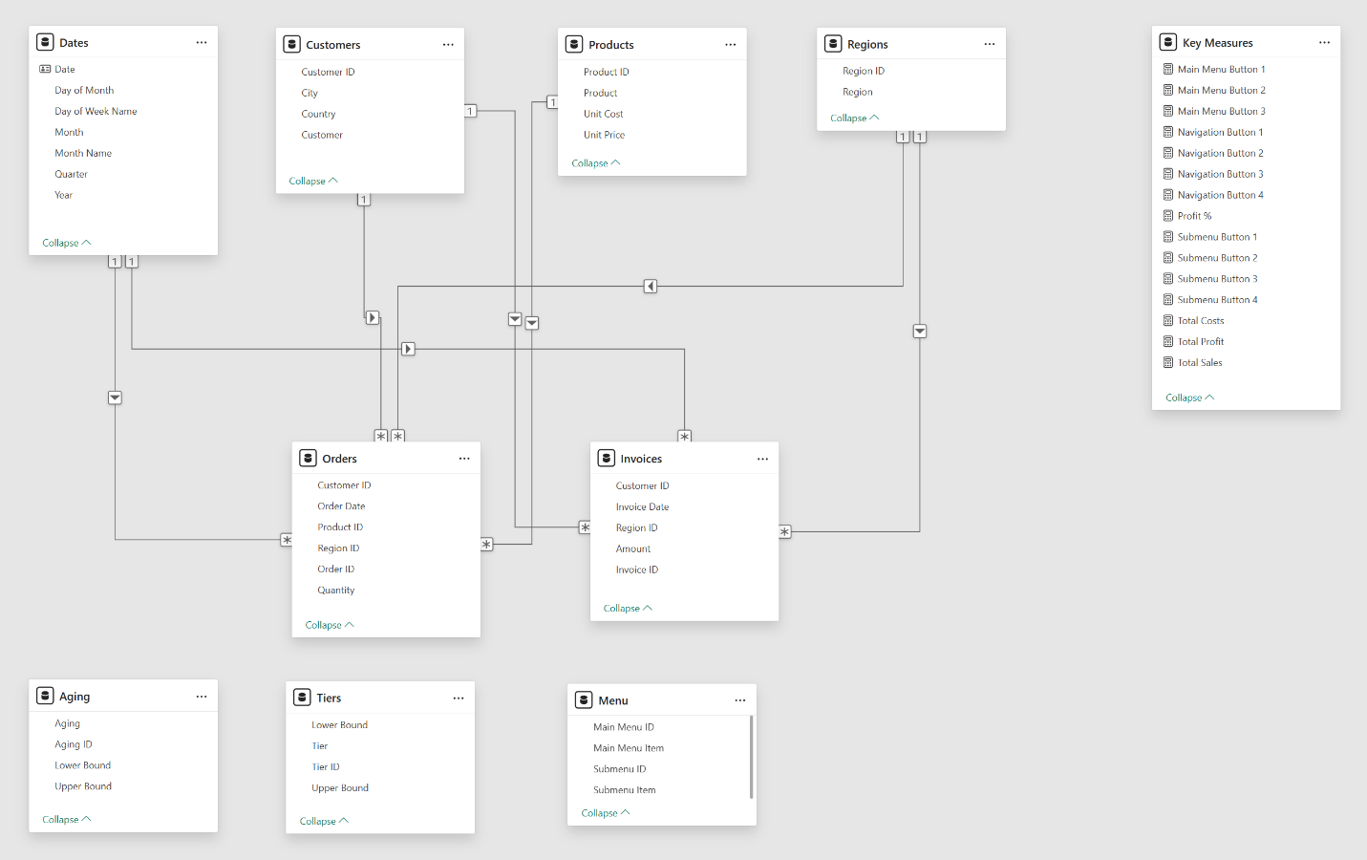

### AR01 – All Invoices

This report shows summary and KPI information about all invoices, and includes the following:

Filters:

* none

Slicers:

* Fiscal year and fiscal quarter hierarchy
* Province and city hierarchy
* Customers

KPIs:

* Count of customers
* Count of invoices
* Total invoice amount
* Total invoice outstanding amo9unt
* Earliest invoice date
* Latest invoice date

Gauges:

* Paid invoice amount vs. total invoice amounts
* Outstanding invoice amount vs. total invoice amounts

Horizontal bar charts:

* Total invoice amounts by province
* Total invoice amounts by payment method

### AR02 – Current Invoices

This report shows detailed information about unpaid invoices (with aging), and includes the following:

Filters:

* Invoices[Status] != PAID
* Invoices[Status] IN { ISSUED, OVERDUE }

Slicers:

* Fiscal year
* Fiscal quarter
* Province
* City
* Customers
* Payment method, Funds centre, Cost centre, Material type

KPIs:

* Total invoice amount
* Total invoice paid amount
* Total invoice outstanding amount

Matrix:

* Customers on rows
* Invoice aging groups on columns

Table:

* Columns for invoice aging group, outstanding invoice amount per group, outstanding invoice amount percentage of total per group (percentage with data bars)
* Horizontal bar chart:
  + Outstanding invoices by customer

### AR03 – Upcoming Invoices

This report shows detailed information about in-process and future invoices, and includes the following:

Filters:

* Invoices[Status] IN { SCHEDULED, DRAFT, IN PROGRESS, APPROVED }

Slicers:

* Fiscal year
* Fiscal quarter
* Province
* City
* Customers

KPIs:

* Total invoice amount
* Total invoice paid amount
* Total invoice outstanding amount

Table:

* Invoice detail, with columns for customer, order/project ID, (temporary placeholder) invoice number, (anticipated) amount, (scheduled) invoice date

### AR04 – Historical Invoices

This report shows detailed information about paid invoices, and includes the following:

Filters:

* Invoices[Status] = PAID

Slicers:

* Fiscal year
* Fiscal quarter
* Province
* City
* Customers

Maps:

* Invoice amount by city
* Outstanding invoice amount by city

*-- end of fragment*